**Biomedical Research Funding-at-a-Glance ALABAMA**

**National Institutes of Health Funding for Alabama1**

* In FY2016, Alabama received 654 NIH-funded grants through normal appropriations process, totaling $294,964,217.
* This represents an increase of about $15 million from FY2015 and 44 more grants.

**National Science Foundation Funding for Alabama2**

* In FY2016, NSF provided 177 awards totaling $46,041,000.

**NIH Helping** **Communities**

***What does NIH funding mean for the Alabama economy?***

* In FY2007, each NIH dollar invested in Alabama generated $2.26 in new state business activity**3**.
* In FY2016, the NIH supported $706.6 million in economic activity and 4,604 jobs**4**.

***Life Science Industry Impact***

* The life science industry in Alabama employs approximately 13,000 individuals directly5.
* From 2009 to 2013, more than 620 bioscience patents were awarded5.
* Over 660 bioscience companies are at work with average annual wages of $65,7275.
* Alabama ranks 8th in the U.S. for biopharmaceutical job creation6.

**Scientific developments made possible through NIH Funding5**

* Discovery of seven cancer fighting drugs currently in use.
* Discovery of six cancer fighting drugs currently in advanced testing.
* Evaluation of about half of the cancer drugs currently on the market for patients.
* Production of 9.3 million high-tech, blood-filtering dialyzers in just under 2 years.

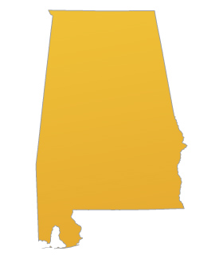

$3.7 billion annual R&D expenditures were made in 20146

As of September 2016, there were 7,675 clinical trials in Alabama 7

“The impact of Alabama’s biotech industry can be measured far beyond the borders of our state, and will no doubt be felt for generations to come5.”



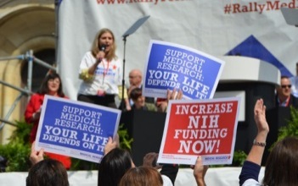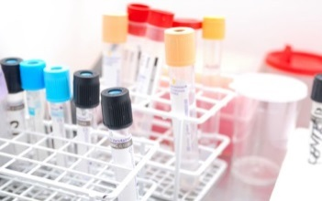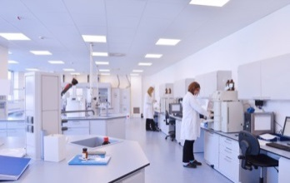

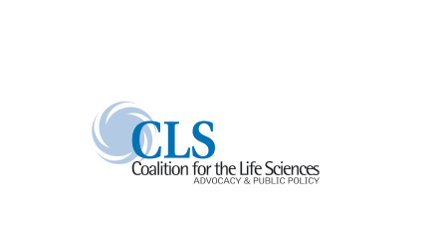

1All information current as of 5/2016, as stated a[t www.nih.gov](http://www.nih.gov/)

2All information current as of 5/2016, as stated a[t www.nsf.gov](http://www.nsf.gov/)

3In Your Own Backyard: How NIH Funding Helps Your State’s Economy, Families USA’s Global Health Initiative, June 2008

4United for Medical Research Report, NIH by state 2016

5All information current as of 5/2015, as stated by Alabama Biotech Industries and Science, Made in Alabama

6Birmingham Business Alliance

7Clinicaltrials.gov, NIH 2016